

**Safeguarding Bulletin**

**Michaelmas Term 2024 ~ Issue 02**

Dear Parents and Guardians,

Welcome to our newsletter from the Safeguarding Team at Bredon School. Our aim is to provide you with the latest support and advice which could affect you and your children’s lives.

**AI-generated Images or Deepfakes**

Internet Matters has published a report on children’s experiences of nude deepfakes, AI-generated or manipulated images or videos made to look real. The report estimates that 13% of UK teenagers have had an experience with a nude deepfake, including sending or receiving one, encountering a nude deepfake online or using a 'nudifying' app. The report presents the findings of a survey with 2,000 parents and 1,000 children. Findings include: most families have little to no understanding of deepfakes; over half of teenagers believe it would be worse to have a deepfake nude of them shared than a real image; and 'nudifying' tools are more often used to create deepfakes of women and girls than boys. The report recommends a ban on 'nudifying' tools and calls for reforms to the school curriculum so children are taught to use AI technology responsibly.

Read the report: [New report estimates half a million UK teenagers have encountered AI-generated nude deepfakes](https://email.nspcc.org.uk/c/14rz4yyGV8XaZqlN3VPHYspT83L)

*Source: Internet Matters, 2024*

**Harmony at Home:**

**Support for Families Across Worcestershire**



"Harmony at Home" is Worcestershire's way of addressing the issue of parents arguing and the impact it has on their children. This effort is part of a broader initiative called the **Reducing Parental Conflict (RPC)** project, which is in partnership with the Department for Work and Pensions (DWP) and organisations from out multi-agency reference group.

Harmony at Home understands all relationships have challenges, difficulties and breakdown, especially with the pressures of being a parent.

Whether you’re navigating parenting challenges, seeking activities to engage your child, or accessing community resources, Harmony Home connects you with professionals and helpful tools to create a nurturing home environment.

Visit [Harmony at Home](https://www.worcestershire.gov.uk/council-services/childrens-social-care/virtual-family-hub/harmony-home) for more details and support options.

**How to Talk to Your Child About Consent**



Consent is an essential part of healthy relationships and everyday interactions, yet many parents find it challenging to discuss this topic with their children. Brook specialists Nicola Rowe and Rachel Balshaw share practical steps to make these conversations easier and more impactful.

**Why Consent Matters:**

* **It’s About More Than Sex**: Teaching children that their body is their own helps establish the foundation for understanding consent, whether it’s saying **“no”** to a hug or deciding on personal boundaries.
* **Promoting Respect**: Consent reinforces the importance of mutual respect and clear communication in relationships.
* **Inclusion for All**: For children requiring intimate care, such as those with disabilities, teaching that they always have a choice is vital.

**Key Lessons About Consent:**

1. **Enthusiastic Consent**: Consent should be a clear and enthusiastic **“yes,”** supported by positive body language and tone. Teach children to recognise when someone’s response is uncertain and encourage them to check in.
2. **The Right to Withdraw**: Consent can be withdrawn at any time, regardless of the situation, ensuring children understand their right to change their mind.

**Tips for Parents to Start the Conversation:**

1. **Start Small**: Bring up the topic casually during shared activities like driving or cooking.
2. **Use Media**: TV, films, or social media can highlight examples of consent and provide natural discussion points.
3. **Be Persistent**: If your child resists talking, try alternative approaches like sharing articles or resources through messaging.
4. **Normalise Consent**: Frame it as part of everyday life, reinforcing that their body, space, and choices are always theirs to control.

Talking about consent helps build trust and ensures your child knows they can approach you with questions or concerns. For more resources on this topic, visit the [Brook website](https://www.brook.org.uk/blog/how-to-talk-to-your-child-about-consent/).

*Source: Brook, 2024*

**Children and Violence**

**The Youth Endowment Fund (YEF)** has published the next two reports as part of its annual Children, violence and vulnerability research. The YEF surveyed over **10,000 13- to 17-year-olds** in England and Wales about their experiences of violence. The third report focuses on girls’ and boys’ experiences of violence. Findings include that **24%** of **boys** and **16%** of **girls** said they had been a victim of violence in the past year.

The report highlights the importance of education and support in promoting healthy relationships among children and young people, with findings indicating that these lessons are not universally taught or consistently reaching those who need them the most. The fourth report explores what young people think about the police.  
  
**Read report three:**[How do boys and girls experience violence?](https://email.nspcc.org.uk/c/14xZYOvVOGVPRwYYhrYYxuhl0x5)**Read report four:**[What do children and young people think about the police?](https://email.nspcc.org.uk/c/14xZYWiEtw6kOY2wqBx33T3Dlsi)

*Source: NSPCC, 2024*

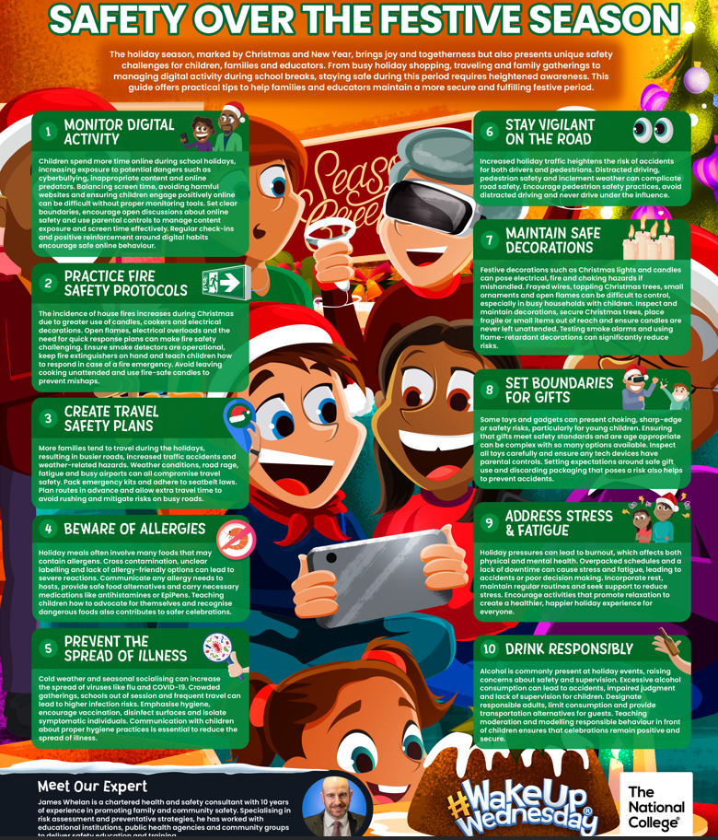

**Staying Safe on Public Transport**

Public transport is a lifeline for many, but it’s important to stay vigilant and prepared. Criminal activities, including exploitation through **County Lines**, do occur, so understanding the risks and adopting safe practices is essential.

**Key Safety Tips for Children and Parents:**

1. **Stay Visible and Alert:** Stick to well-lit and busy areas while waiting for buses or trains. Avoid isolated stops or carriages.
2. **Travel in Groups:** Encourage children to travel with friends whenever possible. There’s safety in numbers.
3. **Avoid Distractions:** Keep phones and headphones away when boarding, exiting, or waiting. Being alert helps you notice your surroundings.
4. **Keep Valuables Hidden:** Ensure phones, wallets, and other valuables are out of sight to avoid becoming a target.
5. **Plan Your Journey:** Use apps or maps to know your route beforehand, minimising unnecessary stops or confusion.
6. **Emergency Contacts:** Teach children to memorise or store emergency numbers and ensure they know how to contact trusted adults if they feel unsafe.
7. **Know the Signs of Exploitation:** Adults and children should learn to recognise unusual behaviour, such as someone being overly controlling or a young person appearing distressed.
8. **Sit Near Safety Points:** On trains or buses, sit near the driver, conductor, or CCTV cameras.

**Being an Active Bystander:**  
If you notice suspicious or harmful behaviours:

* Report them to transport staff, police, or via apps like **British Transport Police's Text 61016**.
* Only intervene if it’s safe to do so.

**After an Incident:**  
Supporting someone after an unsettling experience can make a significant difference. Offer reassurance, help them report incidents, and remind them they’re not alone.

By working together, we can make public transport a safer space for everyone. If you’d like more information or resources, feel free to reach out to local safety organizations or visit British Transport Police.

**Child Trafficking**

**ECPAT UK and the Independent Anti-Slavery Commissioner** have published a new report providing an overview of child trafficking in the UK between 2022 and 2024. The report explores: key concerns for children at risk of and affected by trafficking; the Government’s efforts to prevent child trafficking in the UK and protect those who have been trafficked; and prosecutions and convictions for child trafficking. Recommendations call for the Government to invest in long-term prevention with a cross-departmental UK-wide child exploitation strategy and to integrate a human-rights-based approach across all anti-trafficking efforts.

**Read the report:**[UK Government urged to act on trafficked children’s rights amid systemic failures](https://email.nspcc.org.uk/c/14xZZ45n8lgPMp64zL57AhPVGnv)

*Source: NSPCC, 2024*

**Protecting Children from Trafficking and Modern Slavery**

Child trafficking is a serious form of child abuse that involves recruiting, moving, or harbouring children for exploitation. This can include sexual exploitation, forced labour, domestic servitude, and involvement in criminal activities. Children may be trafficked into the UK from other countries or moved within the UK itself.

**How Trafficking Happens:** Traffickers often use grooming techniques to gain the trust of a child or their family, sometimes deceiving, coercing, or persuading children to leave their homes. This exploitation can occur through organized criminal networks or individuals.

**Signs a Child Might Be Trafficked:** As a parent, it's important to be aware of signs that may indicate a child is being trafficked, such as:

* **Unexplained absences** from school or home.
* **Possession of items** they cannot afford, like new clothes or gadgets.
* **Changes in behaviour**, including becoming withdrawn or anxious.
* **Evidence of physical abuse** or neglect.
* **Relationships with older individuals** or new friends who seem controlling.

**Protecting Your Child:** To help keep your child safe:

* **Maintain open communication**: Encourage your child to talk about their day and any concerns.
* **Educate them about grooming**: Explain how some people may try to build trust for exploitative purposes.
* **Monitor online activity**: Be aware of your child's internet use and who they interact with online.
* **Know their friends and routines**: Stay informed about your child's social circle and daily activities.

**If You're Concerned:** If you suspect a child is being trafficked:

* **Contact the NSPCC Helpline**: Call **0808 800 5000** or email [help@nspcc.org.uk](mailto:help@nspcc.org.uk) for confidential advice.
* **In an emergency**: If a child is in immediate danger, call the police on **999**.

For more detailed information, visit the [NSPCC's page](https://learning.nspcc.org.uk/child-abuse-and-neglect/child-trafficking-and-modern-slavery?utm_campaign=20241216_KIS_CASPAR_December16&utm_content=Protecting%20children%20from%20trafficking%20and%20modern%20slavery&utm_medium=email&utm_source=Adestra) on child trafficking and modern slavery. Remember, staying informed and vigilant is key to protecting children from exploitation.

*Source: NSPCC, 2024*

Best wishes,



Miss Charmain Eaton

**Deputy Head (Pastoral and Safeguarding) & CCF Contingent Commander**

